CC1

727721euit058

Jagadeeshkanna.s

3.

Create a new s3 bucket in the region of stockholm

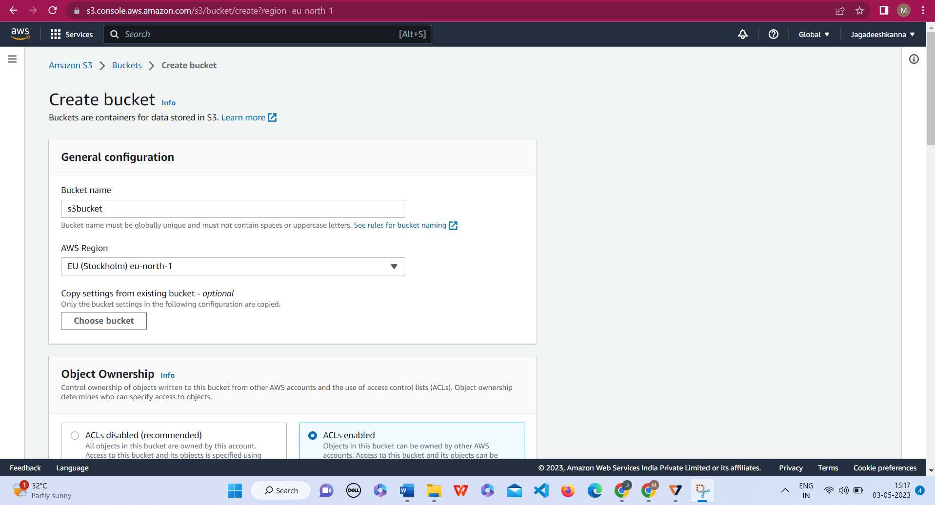

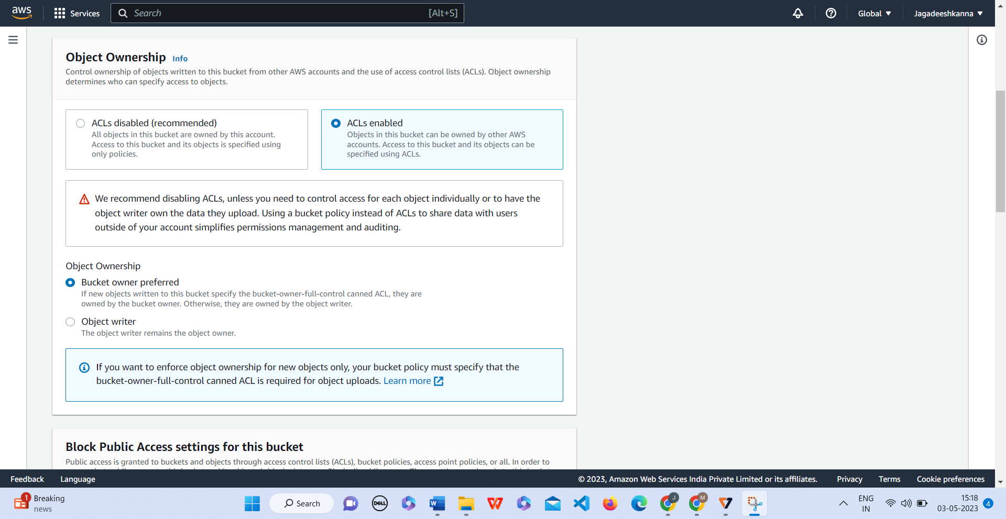

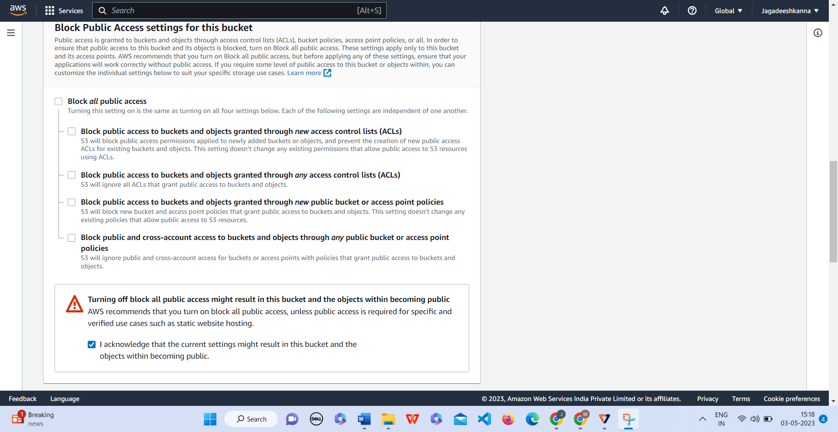

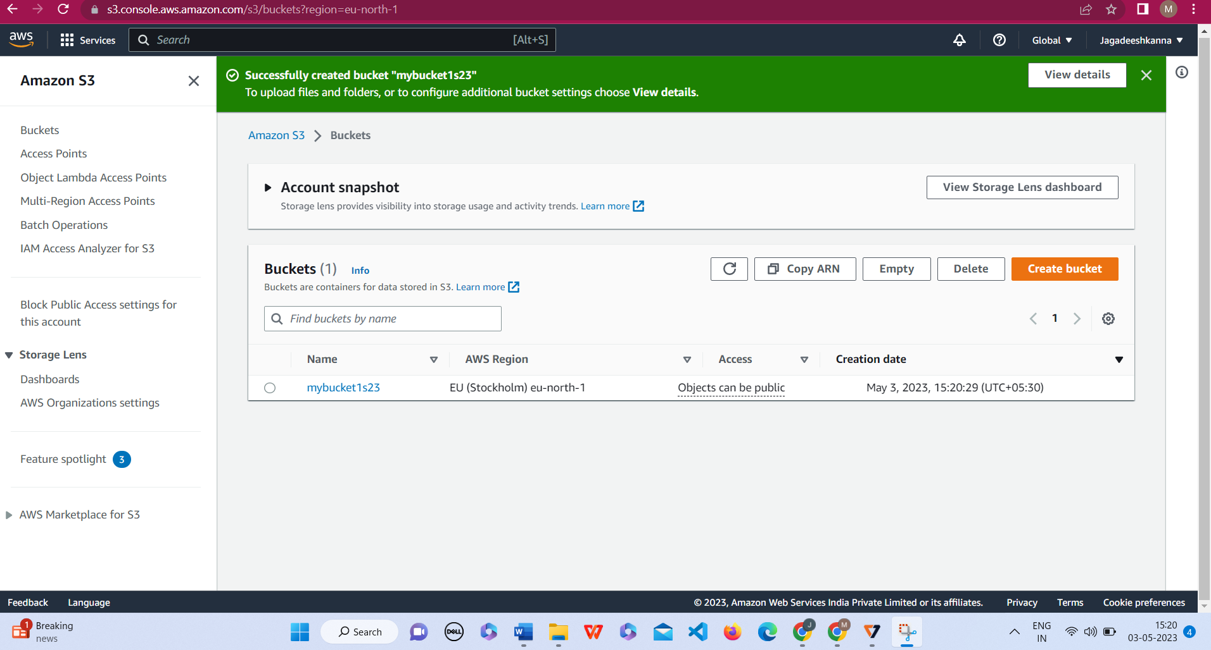

Make the bucket accessible to everyone via bucket ACL

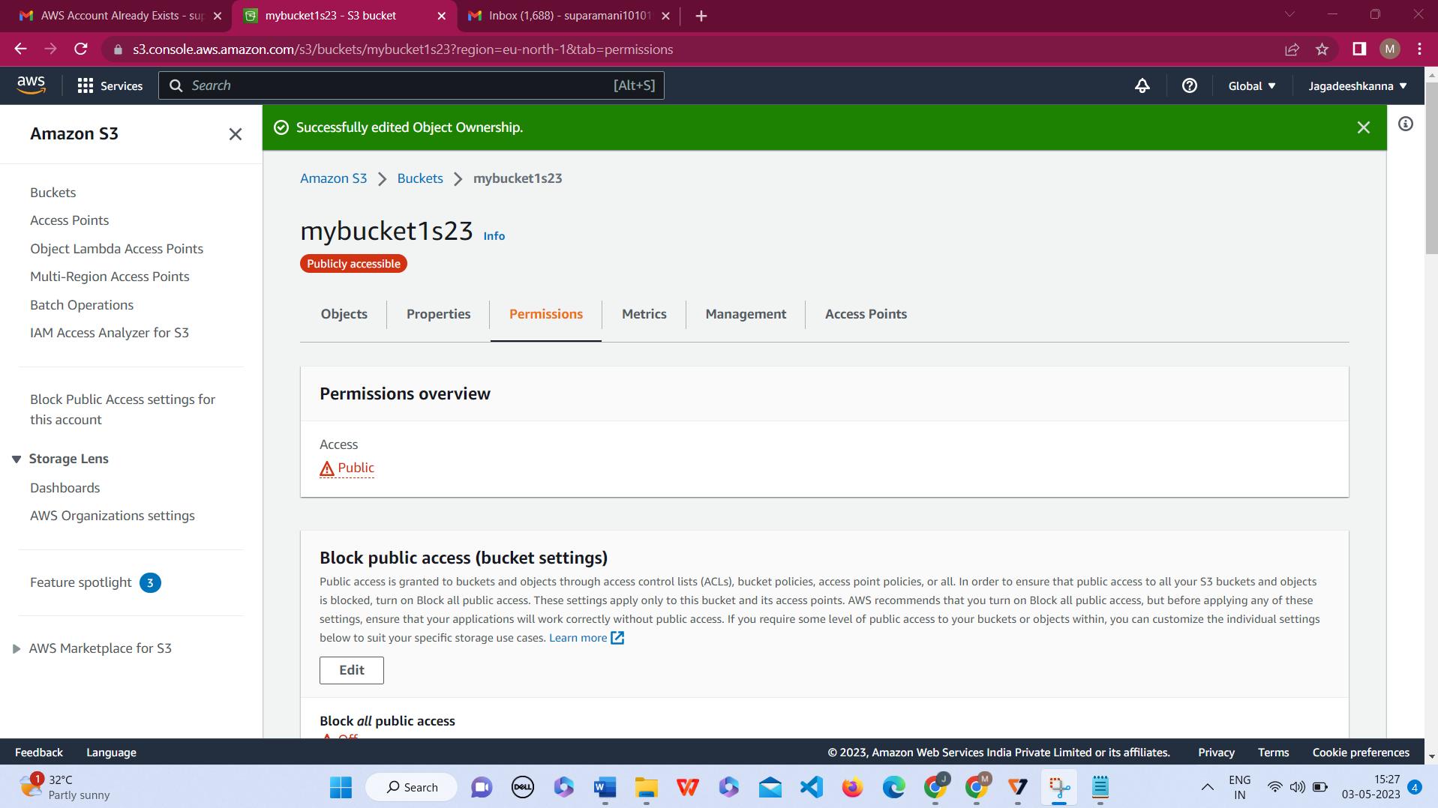

Upload text file in the name of accounts.txt

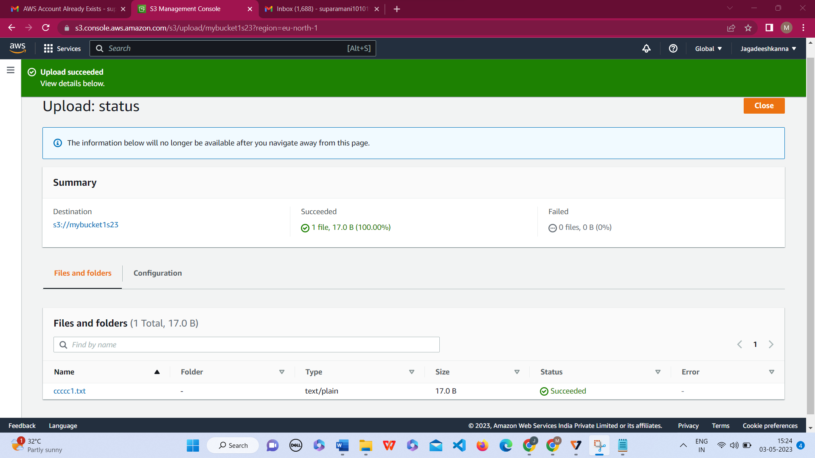

Make the object ‘accounts.txt’ file accessible to everyone

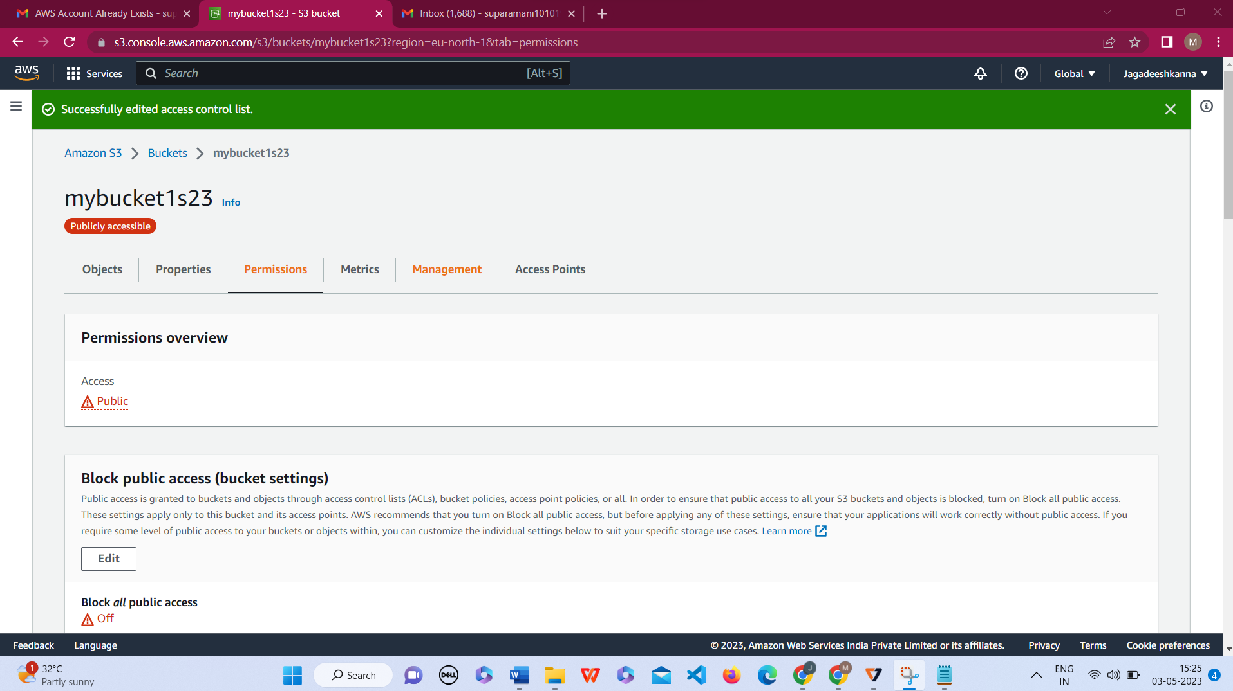

1.)

Give the Name tag of both Ec2 instance and keypair as

“ec2usecase1 “

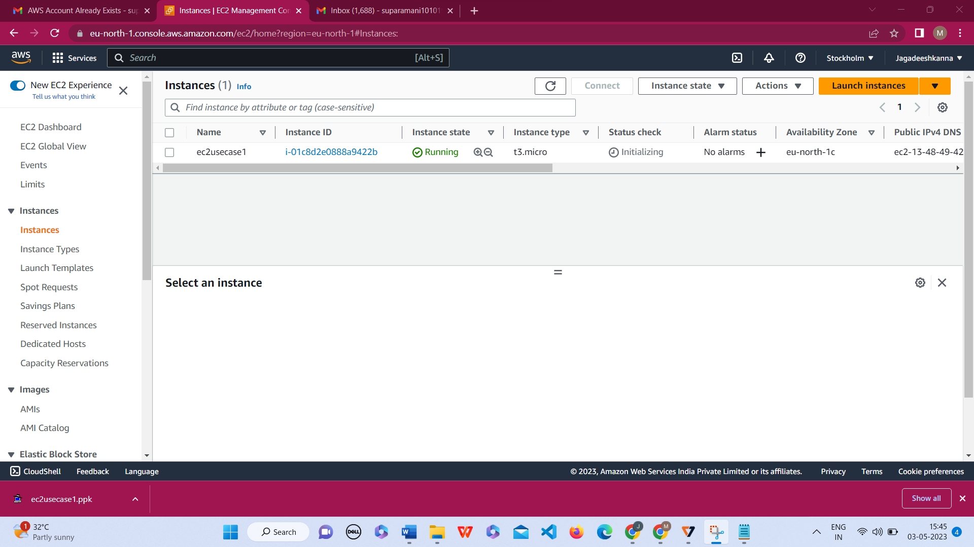

Ec2 instance AMI should be ”Amazon Linux 2”

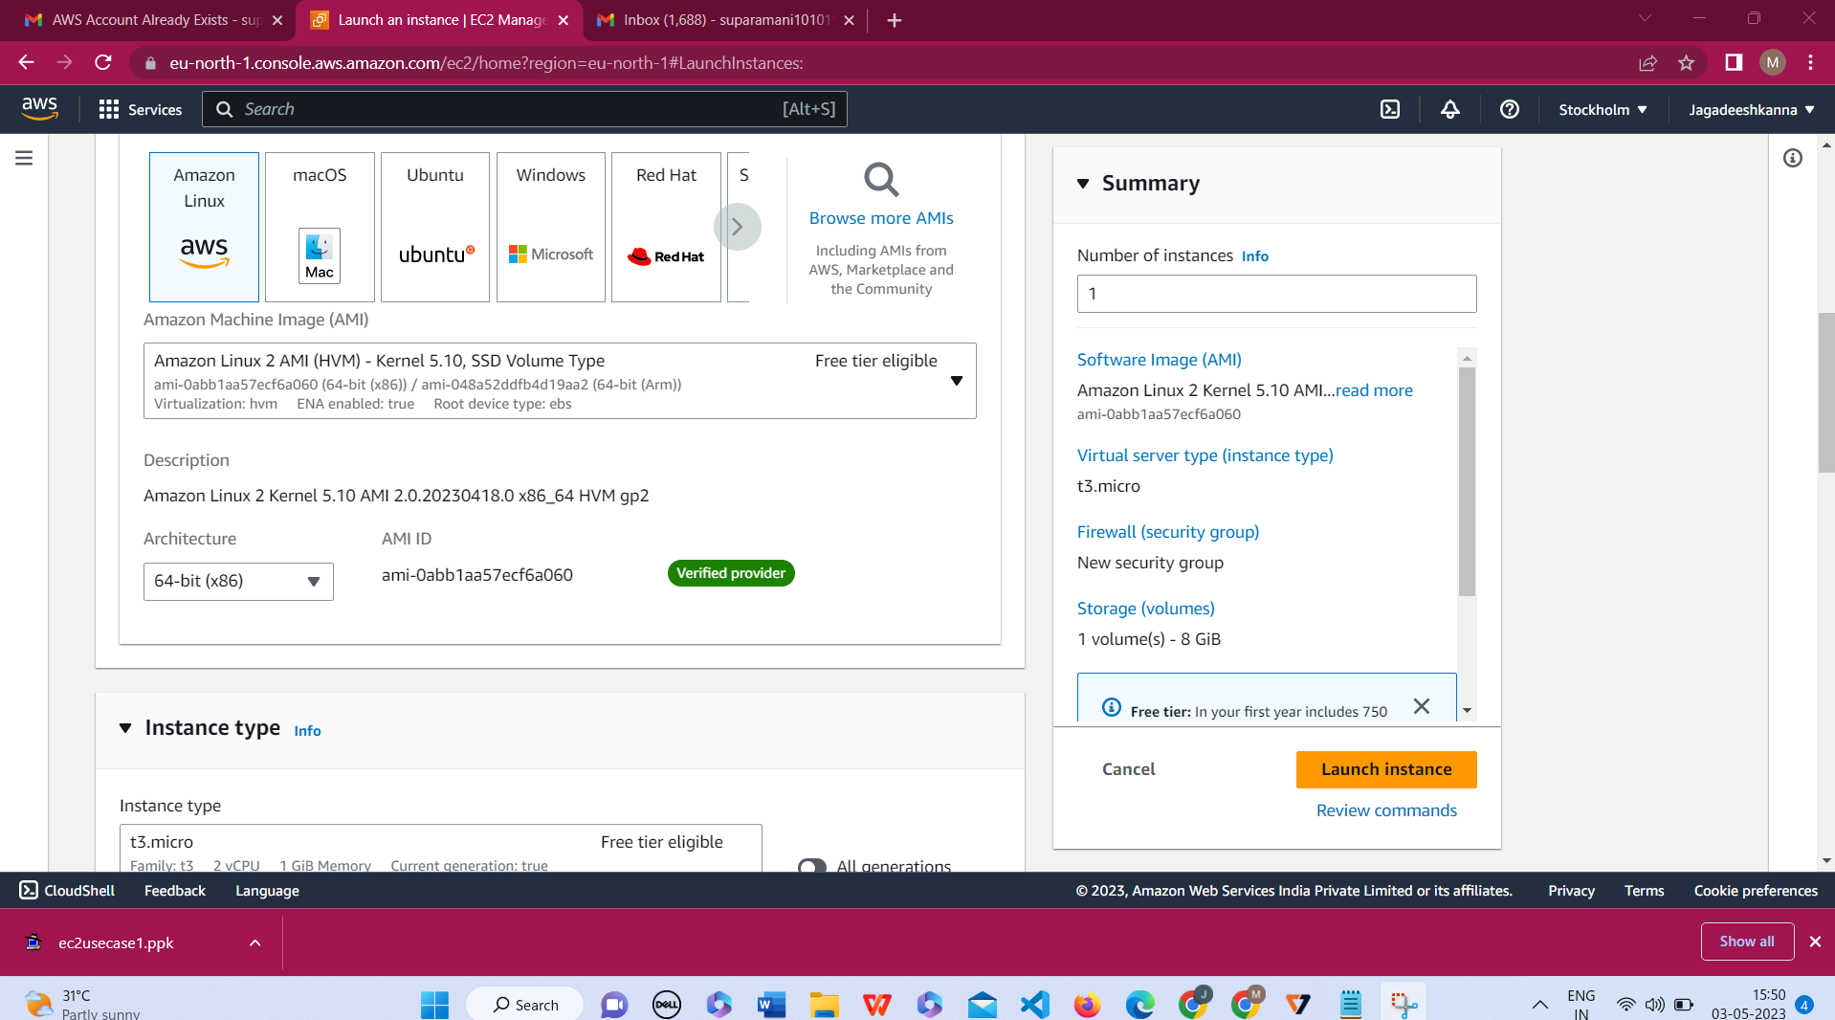

Allow SSH traffic for taking putty remote connection

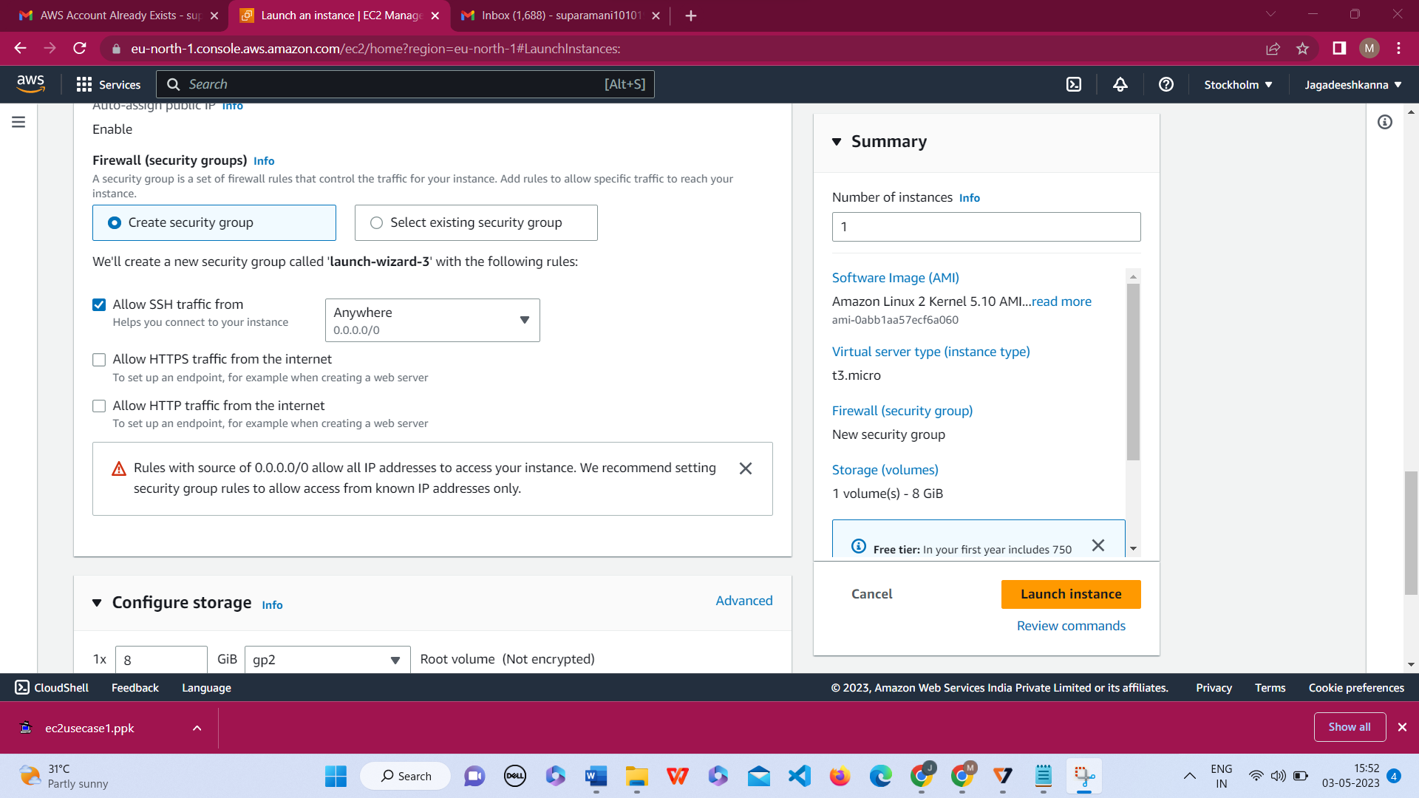

Allow HTTP traffic from the internet for reaching website request

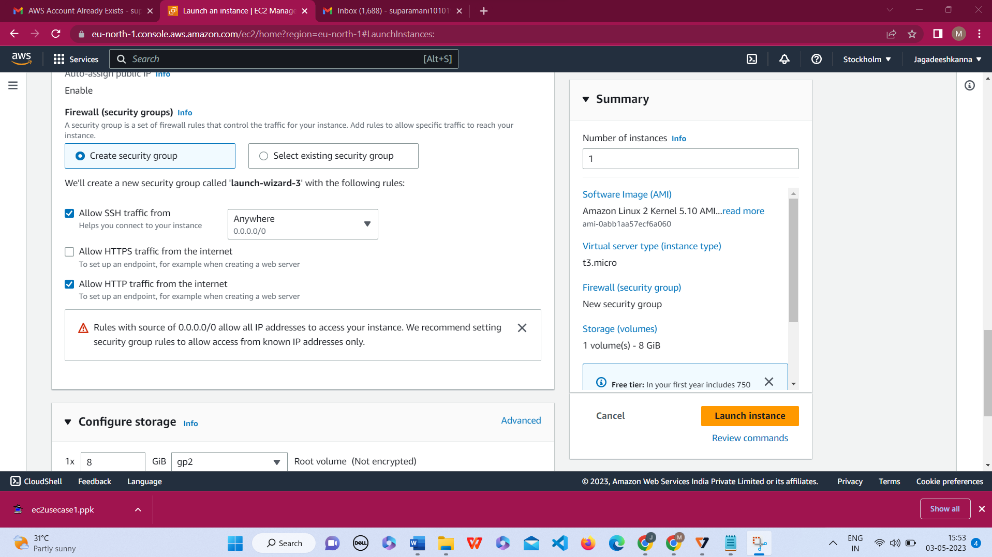

2.)

The name of the IAM group should be ‘Network-L1-Team

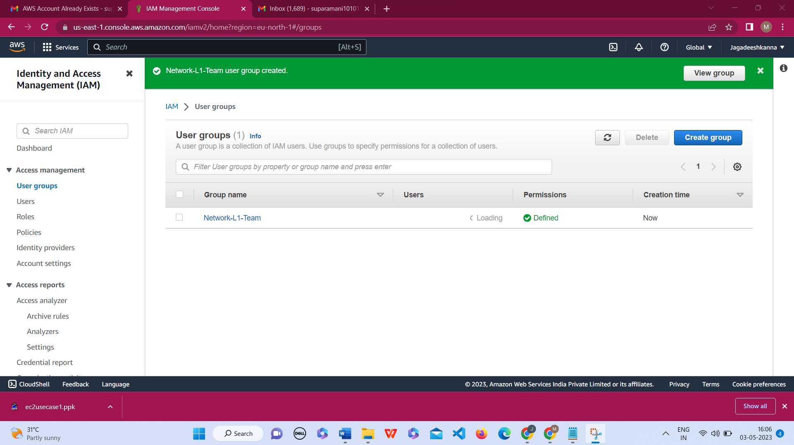

The name of the IAM user should be ‘Network-L1-User1

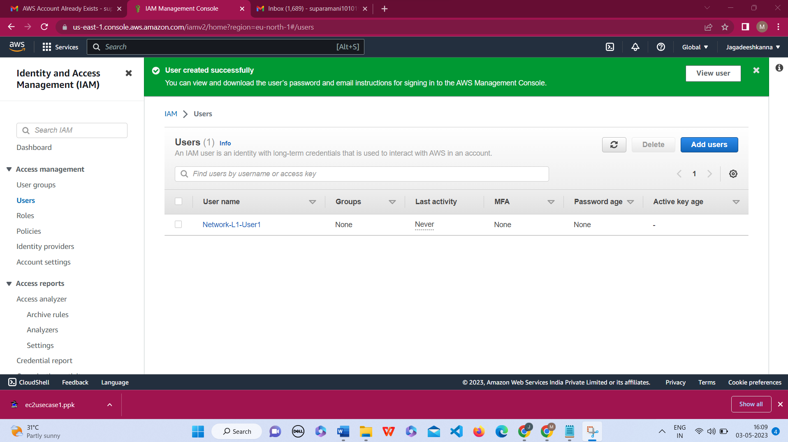

The AmazonVPCReadOnlyAccess policy should be attached

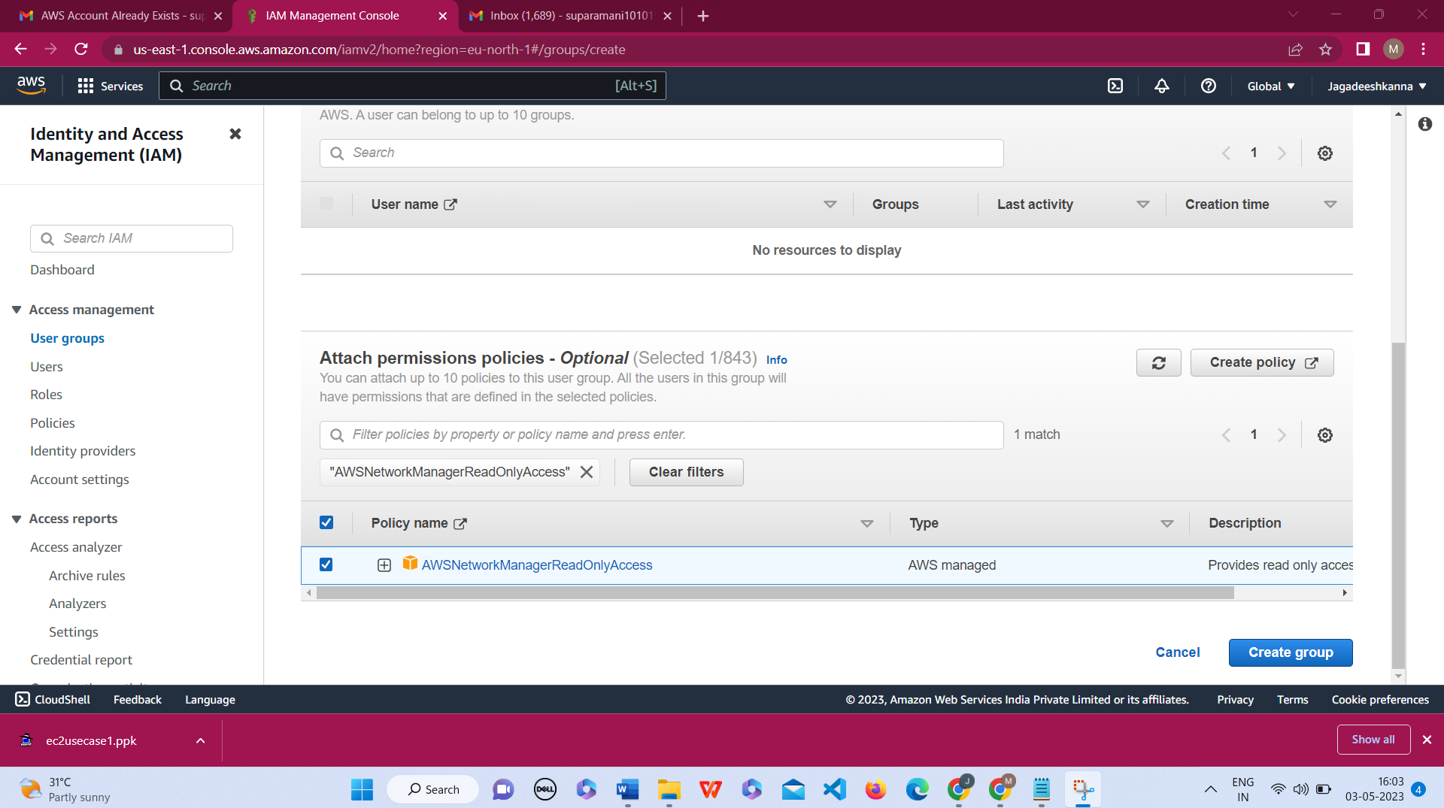

The AWSNetworkManagerReadOnlyAccess

policy should be attached

